VR Critiques Pt 2

DIG 4633C

Dexavier Chang

9/19/2019

Tilt Brush 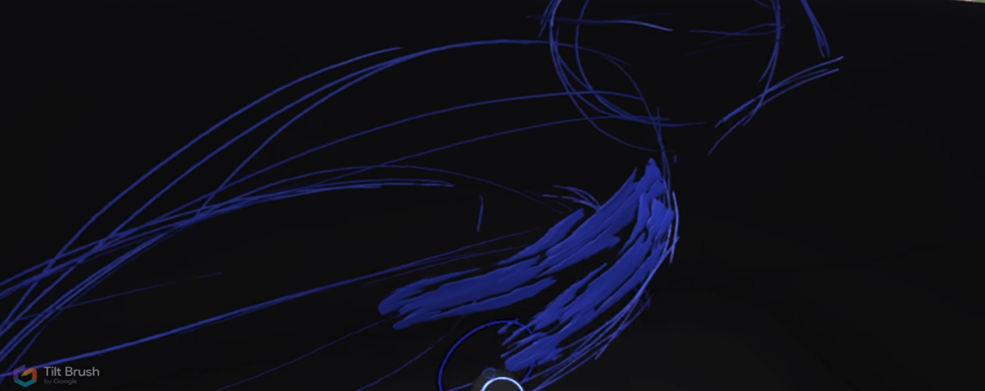

A specific interaction that I experienced with Tilt Brush was with the tools of the virtual palette. Tilt Brush has several brushes and strokes to choose from along with a nice simple array of colors to use. During my playthrough, I interacted with everything that the palette offered me and attempted to create whatever I could think of. Tilt Brush does a good job at creating a nice serene three-dimensional environment for artists to create in vr. People across all ages may or may be unable to get into it, but it was a decent experience at best for me.

Three common themes I noticed were it was Photoshop in virtual reality, a nice way to introduce non-gamers to vr, and non-artists can get into it. There were several online reviewers who pointed out how it is like Photoshop because of the endless choices for creations. Many other reviewers pointed out that you can get people interested in vr with this since you are one-hundred percent in control. The last ongoing theme is non-artists can have fun with this title. You don’t need any art experience to be able to enjoy the game, and that was stressed in several reviews.

I encountered no hardware problems when I used Tilt Brush. All the palettes, backgrounds, and brushes worked just fine. Using the controller to transport myself to other drawings also went well. The experience was fun for a little bit but as time passed, I became rather bored and saw it as pointless. Even though everything worked the way that it was supposed to, I honestly feel like this sort of game isn’t meant for virtual reality. I see no reason as to why people would play this compared to any other online drawing program or any other virtual reality game.

Beat Saber

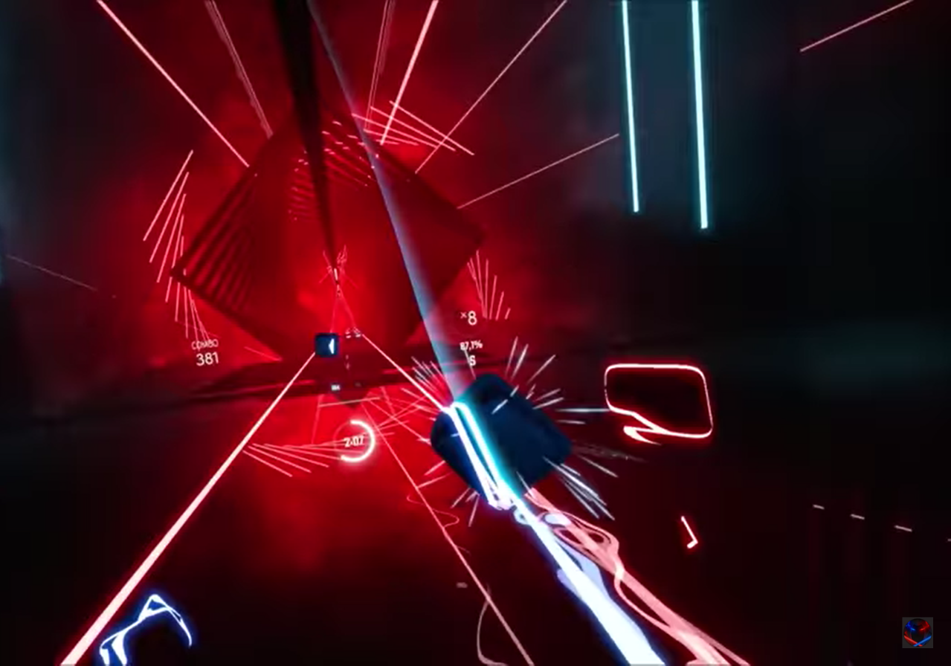

Beat Saber, in my opinion, is a game meant for vr. I loved the straightforward concept of color coordinating saber to cube hits for each level or mission. I also liked how they threw in walls that the player would have to avoid while on beat. It works well in that it offers variety in the form or multiple modes and provides a nice workout. After I was done playing this game, it felt like a worthwhile experience as it took full advantage of the vr technology. It’s nice to see rhythm games making a comeback with the newest technology.

Three common themes I noticed were it was a great workout, it has addictive gameplay and that the music is horrible. Many reviewers mentioned that the game forces you to move whether it’s to the rhythm or to avoid hurdles. Many reviews praised the gameplay. Beat Saber very easy to learn and once you do it’s impossible to get unhooked. One of the main aspects of the game is how the music mixes in with the gameplay. Several people complained about how the music is a horrible mix of rap and rock and that the solution was to download mods.

Everything worked well with this game. The cube cutting mechanics worked well. The dodging and maneuvering around walls worked well. This game was built for virtual reality as every single interaction I had went well. The main way this works is by not overcomplicating anything. The gameplay is simple to the point that anybody can easily get into it. In terms of interactions with the hardware, I can honestly say this was one of my best experiences in this class. The designers created a fun game that could essentially get people interested in virtual reality and resurrect the rhythm genre.

Space Pirate Trainer

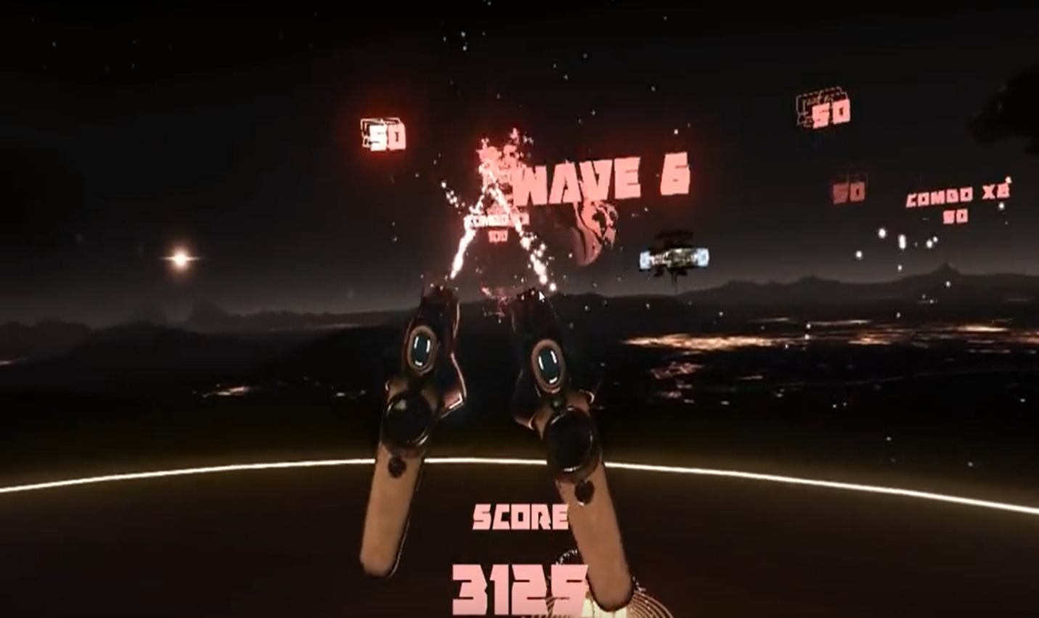

Being that Space Pirate is a first-person shooter I want to mainly talk about that interaction and how it impacted me. The shooting mechanics worked well with vr. It was a fun experience dodging projectiles in slow motion and returning fire. This game reminds me of the arcade shooter Time Crisis. I have a very mixed reaction when it comes to first-person shooters, but Space Pirate Trainer changes that. The fun of this genre is increased when you’re inside of the game. I was so impressed with how the game played that I didn’t even know you could combine weapons.

Three common themes that I noticed were that is like an arcade shooter, it is very simple, and it has high replay value. Several reviewers compared it to the arcade games Galaga and Space Invaders. These comparisons come from the fact that you are in space shooting at enemies. The reviewers took a page out of my book and complimented on how it is so simple yet so fun. You pick up a gun and go crazy. One of the top things that reviewers said was that you can return anytime and still enjoy it which replicates the arcade feel.

When it comes to Space Pirate Trainer, there isn’t a whole lot to say about the interactions. You shoot, dodge, and shoot some more. Those interactions work well with the vr. There were no weaknesses with the game while using virtual reality. Like I mentioned above in the above critique games that aren’t overcomplicated, tend to work even better with virtual reality. Throughout my sessions, I never experienced any graphical mess-ups or any other problems I could think of. This and Beat Saber are the most straightforward games this week as they don’t use the vr controls to the max.

Red Matter

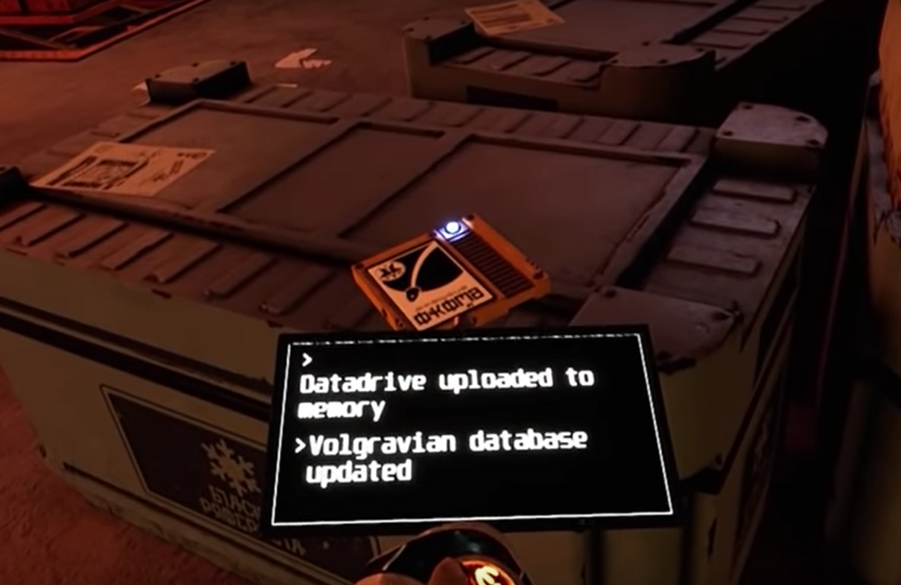

This game has a similar use of its controls to Virtual Reality with the main difference being that your device has many functions. Instead of just being used to transport yourself and throw items, it can be used as a claw and a translator. I loved translating the foreign text around the levels as it helped me get in touch with the story. The more I played, the more I learned about the story as the translator helped me progress. Red Matter was such a fun game to get into because you feel like you’re inside of that world.

Three themes I noticed were it has a great graphical style, plays like escape rooms, and the story is very good. Red Matter has great visuals, so that came to me as no surprise that viewers mentioned it. Almost every review on the pages mentioned how the graphics take the player into the game. People drew comparisons of escape rooms because of the puzzle solving. Even people who didn’t like puzzle games couldn’t help but praise the ease of the puzzles in Red Matter. The whole Cold War like setting was a great plot and other people thought so too as it was mentioned heavily. VR is about taking you into a different world and this game succeeded in it.

The controls worked well and functioned perfectly. When I wanted to translate text, it worked, when I wanted to transport around the level, it worked. I can never find any weaknesses as the technology functioned perfectly during my sessions. To me, the team was able to create a game that worked well with vr. Some games aren’t very simple when it comes to their interactions. This isn’t one of those games as I never encountered a problem with the technology.